Unit5 Task
1. Select all tweets from the tweets table that were tweeted on day 30 of the sample
SELECT *
FROM tweets
WHERE day = 30;

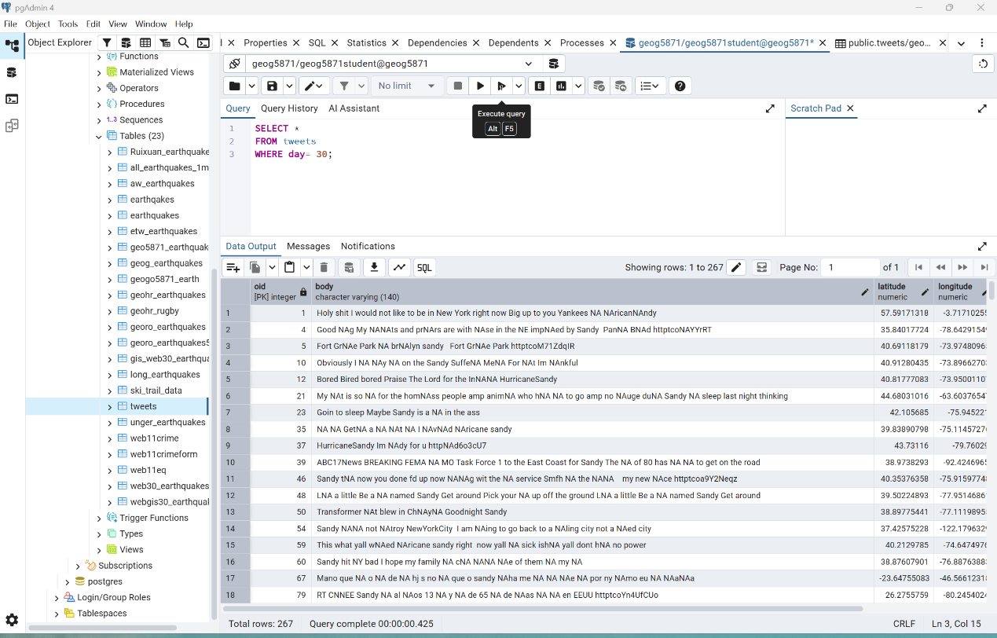

2. Select all tweets from the tweets table that were tweeted on day 30 of the sample and include the keyword 'Hurricane'.
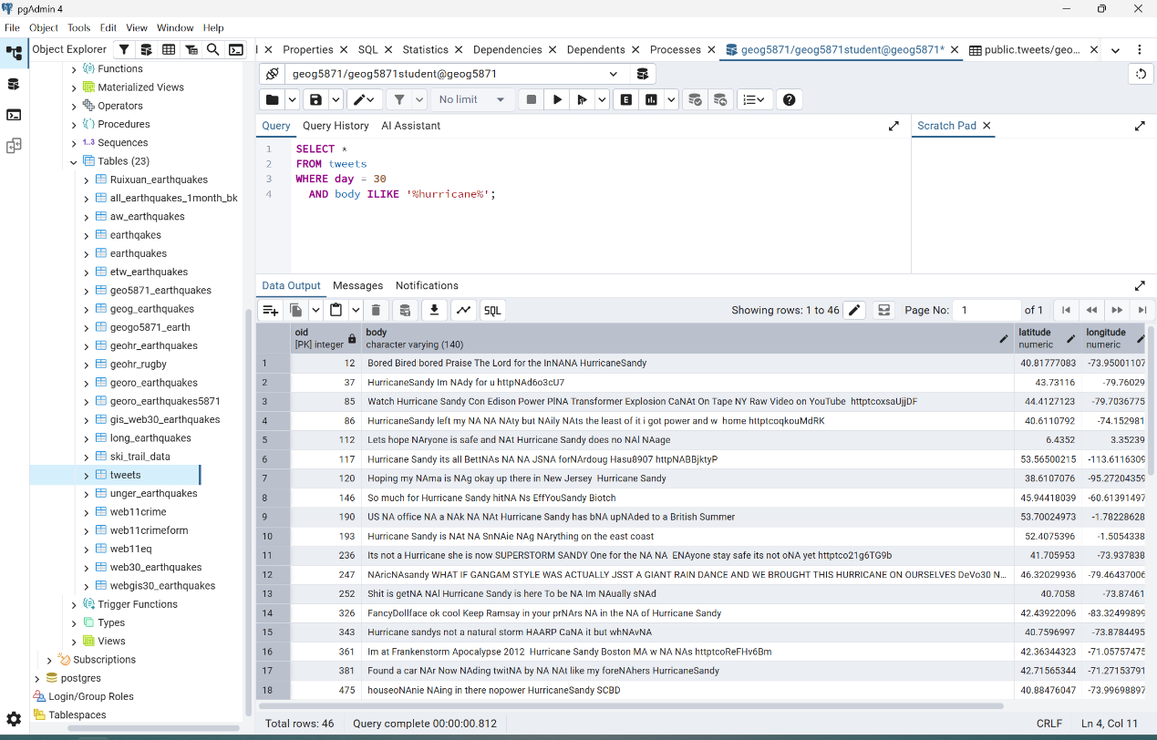
SELECT *
FROM tweets
WHERE day = 30
AND body ILIKE '%hurricane%';

3. Select all records from your Earthquakes table which occurred in Japan and have a depth greater than 70.
SELECT *
FROM web24_earthquakes
WHERE place ILIKE '%japan%'
AND depth > 70;

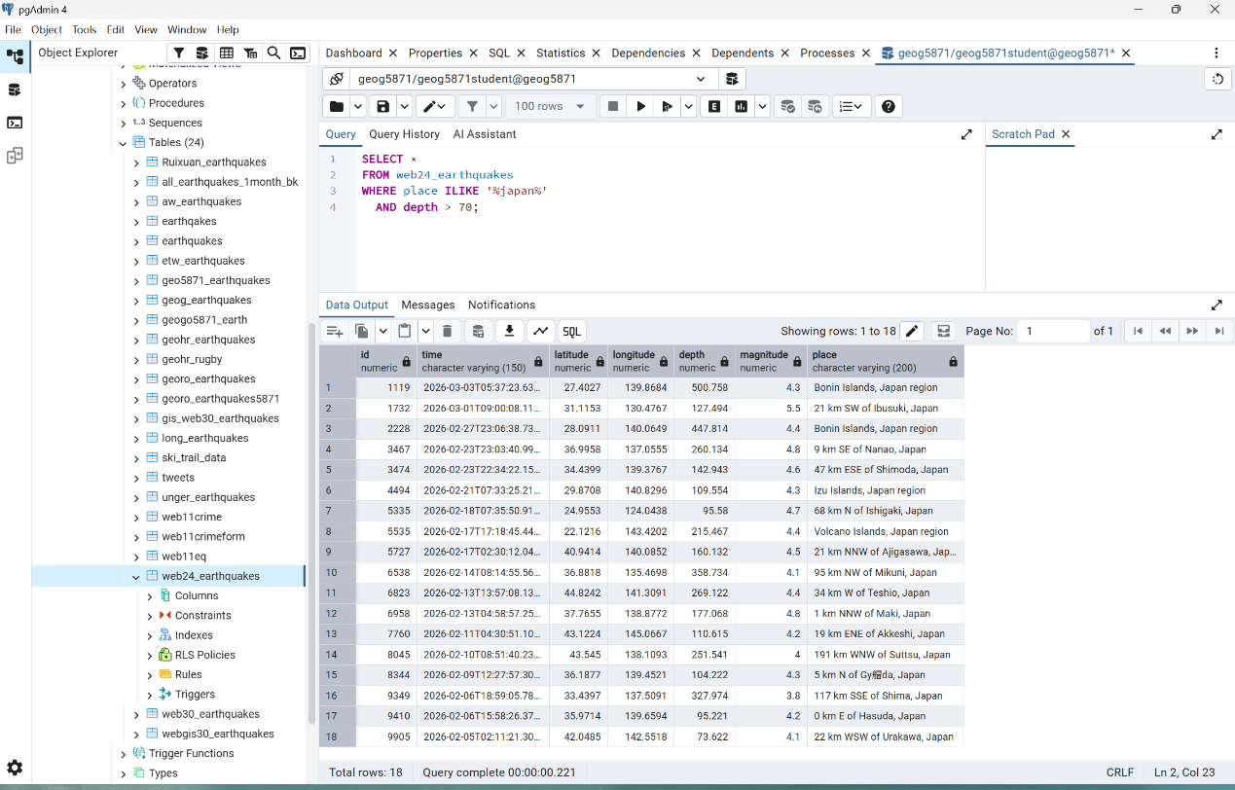

4. Select all records which fall within a geographical bounded area of your choice (a region that has tectonic activity!).
SELECT *
FROM web24_earthquakes
WHERE latitude BETWEEN 32 AND 42
AND longitude BETWEEN -125 AND -114;

The bounded area used in this query is California, USA, which lies along the San Andreas Fault and is a highly tectonically active region.
